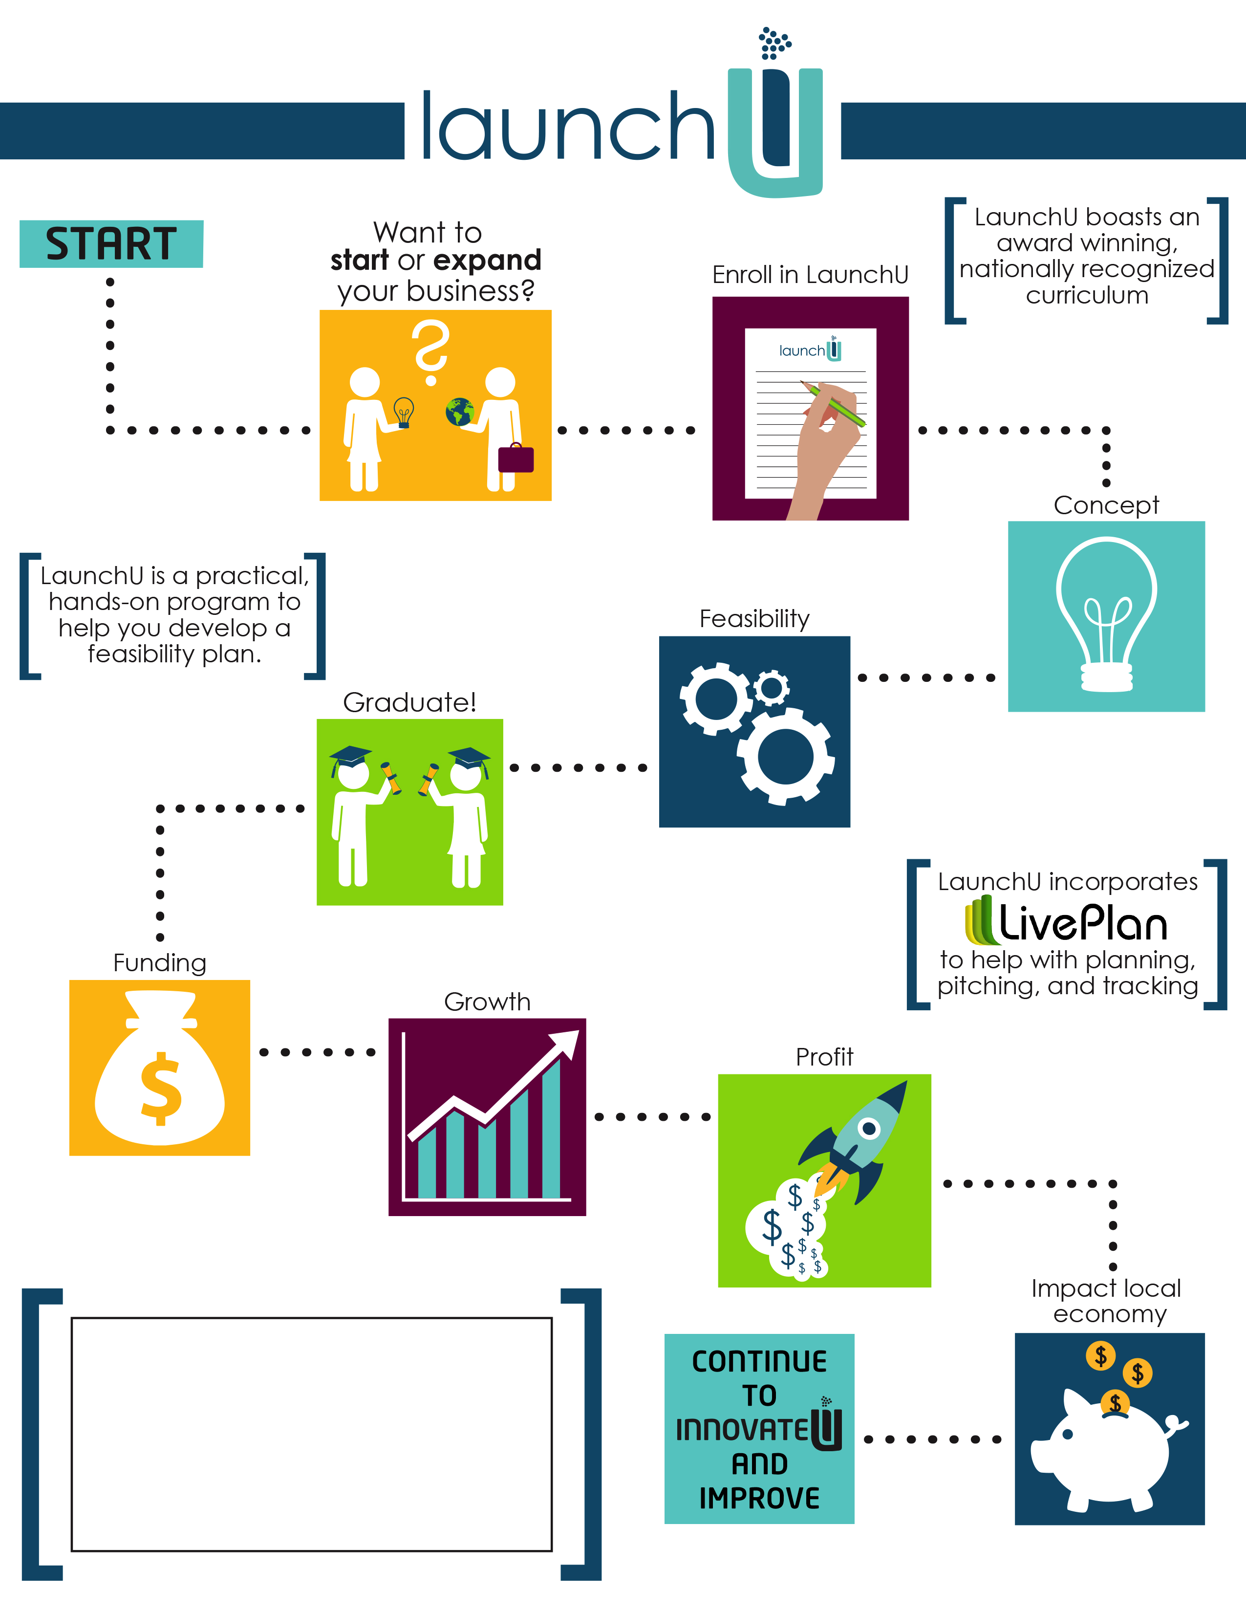

Next Class Starts Soon

***Transfomations ECD will host two Launch U Sessions during 2022.*** *Save your seat for the Zoom Info Session on Thursday, March 10th, 2022 at 6 p.m. Call us at 901-254-8290 or email Sharon at STMckinney@txecd.org*